**Pizza sales KPI**

Analyse key indicators for the pizza sales data to gain insights on the business performance using mySQL Workbench

Walkthrough

I Imported my data from a csv file into MySQL Here is the table overview

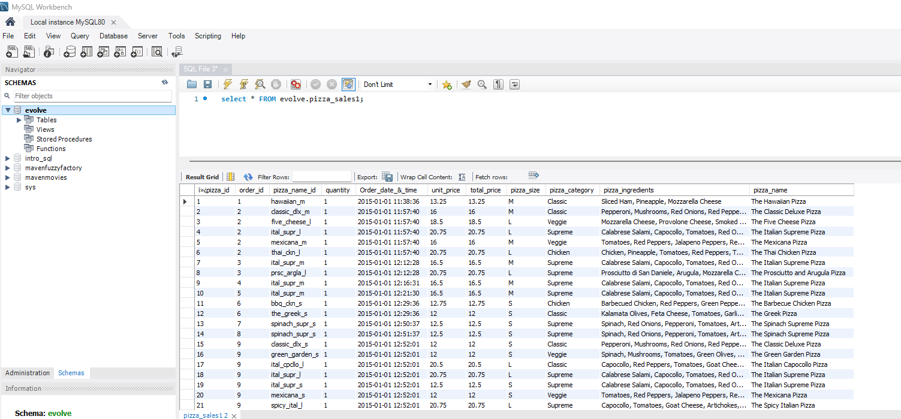

**For Practice I will use the above table Data to Calculate:**

1.Total Revenue

Summed the “total_price” column to get the total revenue using the SUM Function.

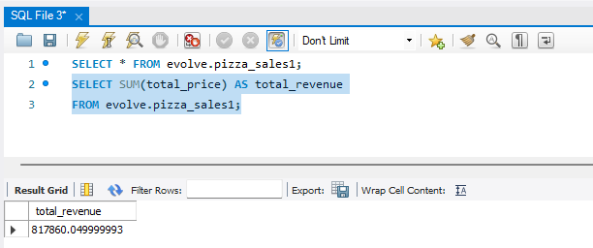

2. Average order value

Calculated the average order value using total_revenue /Order_id(total number of orders)

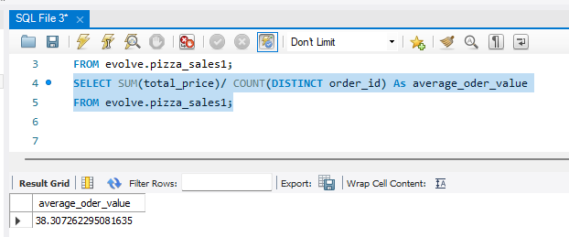

3.Total pizzas sold

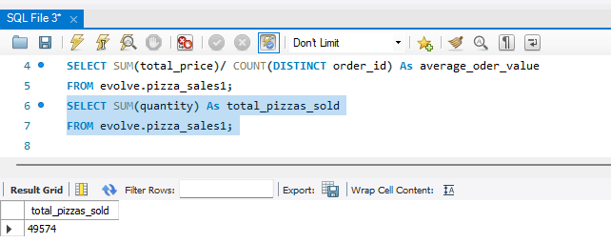

4.Total_Orders

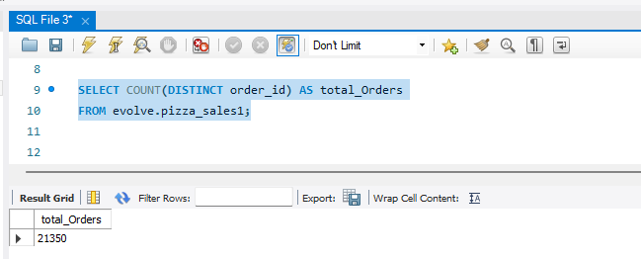

5.Average Pizzas Per Order

Total number of pizzas sold/total number of orders

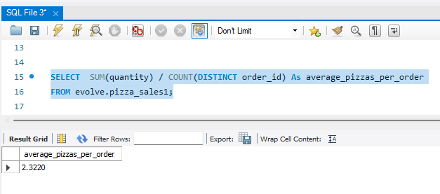

**Here is all the commands I ran**

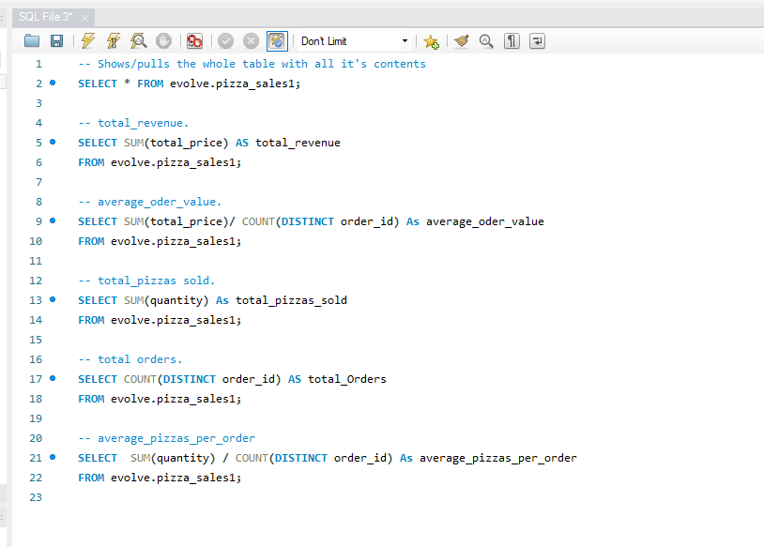

**Data To use for visualization:**

1. **Daily trends for Total orders**

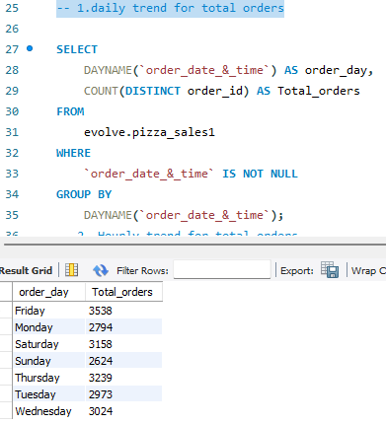

1. **Hourly trend for total orders**

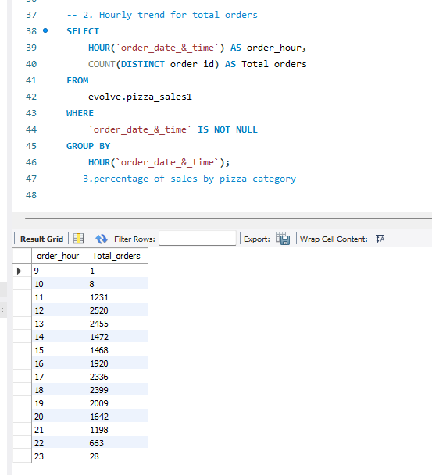

1. **Percentage of sales by pizza category.**

